Sharvan Ram Kumaran

CSE-C

185001143

**Assignment 5-**Implement Profile Servlet using Http Sessions.

**Code:**

**Index.html**

<!DOCTYPE html>

<html lang="en" dir="ltr">

<head>

<meta charset="utf-8">

<title>Login Page</title>

<link rel="stylesheet" href="login_style.css">

</head>

<body>

<form class="box" id="login" action="http://localhost:8080/Profile/LoginServlet">

<h1>Login</h1>

<input type="text" name="username" placeholder="Enter Username" required>

<input type="password" name="password" placeholder="Enter Password" required>

<input type="submit" name="login" value="Login">

<input type="reset" name="reset" value="Clear">

<div class='backDiv'><a href='http://localhost:8080/Profile/LogoutServlet'>Logout</a></div>

</form>

</body>

</html>

**Login_style.css**

html {

background: url(clouds.jpg) no-repeat center center fixed;

-webkit-background-size: cover;

-moz-background-size: cover;

-o-background-size: cover;

background-size: cover;

}

h1{

text-align: center;

font-family: sans-serif;

font-weight: 500;

color: Aqua;

}

.box{

width: 300px;

padding: 40px;

position: absolute;

top:50%;

left: 50%;

transform: translate(-50%,-50%);

background: #191919;

border-radius: 16px;

text-align: center;

}

.box input[type="text"],

.box input[type="password"]{

border:0;

background: none;

margin: 10px auto;

border: 2px solid #3498db;

font-family: menlo;

text-align: center;

padding: 14px 10px;

width: 200px;

outline: none;

color: white;

border-radius: 24px;

transition: 0.25s;

}

.box input[type="text"]:focus,

.box input[type="password"]:focus{

width: 280px;

border-color: #2ecc71;

}

.box input[type="submit"] {

border:0;

background: none;

display: block;

margin: 10px auto;

border: 2px solid #2ecc71;

font-family: menlo;

text-align: center;

padding: 14px 40px;

outline: none;

color: white;

border-radius: 24px;

transition: 0.25s;

cursor: pointer;

}

.box input[type="submit"]:hover{

background: #2ecc71;

}

.box input[type=reset] {

border:0;

background: none;

margin: 2px auto;

border: 2px solid #f53b57;

font-family: menlo;

text-align: center;

padding: 8px 20px;

outline: none;

color: white;

border-radius: 24px;

transition: 0.25s;

cursor: pointer;

}

.box input[type=reset]:hover{

background: #f53b57;

}

.backDiv{

text-align: center;

padding: 10px 1px;

background: none;

border: 2px solid #00a8ff;

border-radius: 24px;

margin: 5px 100px;

cursor: pointer;

transition: 0.25s;

}

.backDiv:hover{

background: #00a8ff;

}

a{

font-family: menlo;

color: white;

}

a:link {

text-decoration: none;

}

a:visited {

text-decoration: none;

}

a:hover {

text-decoration: none;

}

a:active {

text-decoration: none;

}

**LoginServlet.java**

import java.util.*;

import jakarta.servlet.http.*;

import jakarta.servlet.*;

import java.io.*;

import java.sql.*;

public class LoginServlet extends HttpServlet{

public void doGet(HttpServletRequest request, HttpServletResponse response) throws ServletException, IOException {

PrintWriter out = response.getWriter();

String usrname = request.getParameter("username");

String pass = request.getParameter("password");

HttpSession session = request.getSession();

session.setAttribute("Username",usrname);

try {

Class.forName("com.mysql.jdbc.Driver");

Connection conn = DriverManager.getConnection("jdbc:mysql://localhost:3306/Profiles","root","crashgoku17");

Statement stmt = conn.createStatement();

String sql = "select * from profiles where username = '" + usrname + "' and password = '" + pass + "';";

ResultSet rs = stmt.executeQuery(sql);

if(rs.next()) {

response.setContentType("text/html");

out.println("<html><head><title>Welcome!</title><link rel='stylesheet' href='welcome_style.css'></head>");

out.println("<body>");

out.println("<h1 class='fade-in'> Welcome, "+usrname+"</h1><br>");

// out.println("<p class='center'>Hello</p>");

out.println("<form class='form1' id='LoginServlet' action='http://localhost:8080/Profile/ProfileServlet'>");

out.println("<input type='submit' name='View' value='View Profile in Details'>");

out.println("</form>");

out.println("<br><br>");

out.println("</body></html>");

}

else {

out.println("No such record found<br>");

}

stmt.close();

conn.close();

} catch (SQLException sql) {

sql.printStackTrace();

out.println(sql);

} catch (Exception e) {

e.printStackTrace();

out.println(e);

}

}

}

**Welcome_style.css**

html{

background: url(buildings.jpg) no-repeat center center fixed;

-webkit-background-size: cover;

-moz-background-size: cover;

-o-background-size: cover;

background-size: cover;

}

.form1{

position: absolute;

top: 55%;

left:52%;

transform: translate(-50%,-50%);

}

input[type='submit']{

background: none;

border: 2px solid white;

font-family: menlo;

border-radius: 24px;

text-align: center;

padding: 10px 10px;

font-size: 20px;

color: white;

transition: 0.25s;

outline: none;

cursor: pointer;

}

input[type='submit']:hover{

background: white;

color: black

}

.fade-in {

display: inline-block;

font-family: 'menlo';

font-size: 60px;

color: #f5f6fa;

position: absolute;

top: 45%;

left:50%;

transform: translate(-50%,-50%);

margin: 0 20px;

opacity: 1;

animation: fadeIn ease 2s;

-webkit-animation: fadeIn ease 2s;

}

@keyframes fadeIn {

0% {opacity:0;}

100% {opacity:1;}

}

@-webkit-keyframes fadeIn {

0% {opacity:0;}

100% {opacity:1;}

}

**ProfileServlet.java**

import java.util.*;

import jakarta.servlet.http.*;

import jakarta.servlet.*;

import java.io.*;

import java.sql.*;

public class ProfileServlet extends HttpServlet{

public void doGet(HttpServletRequest request, HttpServletResponse response) throws ServletException,IOException{

PrintWriter out = response.getWriter();

HttpSession session = request.getSession();

String username = (String)session.getAttribute("Username");

try{

Class.forName("com.mysql.jdbc.Driver");

Connection conn = DriverManager.getConnection("jdbc:mysql://localhost:3306/Profiles","root","crashgoku17");

Statement stmt = conn.createStatement();

String sql = "select * from profiles where username = '" + username + "';";

ResultSet rs = stmt.executeQuery(sql);

if(rs.next()){

String name = rs.getString("name");

String addr = rs.getString("address");

int age = rs.getInt("age");

out.println("<html><head><title>Profile Page</title>");

out.println("<link rel='stylesheet' href='profile_style.css'></head>");

out.println("<body><h1 class='fade-in'>Welcome, "+username+" to the profile page</h1>");

out.println("<p class='disp'>Name: "+name+"</p>");

out.println("<p class='disp'>Age: "+String.valueOf(age)+"</p>");

out.println("<p class='disp'>Address: "+addr+"</p>");

out.println("<div class='backDiv'><a href='index.html'>Login Page</a></div>");

out.println("</body></html>");

}

else {

out.println("No such record found");

}

stmt.close();

conn.close();

} catch (SQLException sql) {

sql.printStackTrace();

out.println(sql);

} catch (Exception e) {

e.printStackTrace();

out.println(e);

}

}

}

**Profile_style.css**

html{

background: url(bluetree.jpg) no-repeat center center fixed;

-webkit-background-size: cover;

-moz-background-size: cover;

-o-background-size: cover;

background-size: cover;

}

.disp{

text-align: center;

font-family: menlo;

font-size: 35px;

font-weight: 100;

color: white;

opacity: 1;

animation: fadeIn ease 2s;

-webkit-animation: fadeIn ease 2s;

}

.backDiv{

margin: auto;

text-align: center;

padding: 10px 15px;

background: none;

border: 2px solid #00a8ff;

border-radius: 24px;

margin: 0px 500px;

cursor: pointer;

transition: 0.25s;

}

.backDiv:hover{

background: #00a8ff;

}

a{

font-family: menlo;

color: white;

}

a:link {

text-decoration: none;

}

a:visited {

text-decoration: none;

}

a:hover {

text-decoration: none;

}

a:active {

text-decoration: none;

}

.fade-in {

display: inline-block;

font-family: 'menlo';

font-size: 60px;

font-weight: 500;

color: #f5f6fa;

text-align: center;

margin: 80px 280px 50px;

opacity: 1;

animation: fadeIn ease 2s;

-webkit-animation: fadeIn ease 2s;

}

@keyframes fadeIn {

0% {opacity:0;}

100% {opacity:1;}

}

@-webkit-keyframes fadeIn {

0% {opacity:0;}

100% {opacity:1;}

}

**LogoutServlet.java**

import java.util.*;

import jakarta.servlet.http.*;

import jakarta.servlet.*;

import java.io.*;

import java.sql.*;

public class LogoutServlet extends HttpServlet{

public void doGet(HttpServletRequest request, HttpServletResponse response) throws ServletException,IOException{

PrintWriter out = response.getWriter();

HttpSession session = request.getSession();

session.invalidate();

out.println("<html><head><title>Logout</title>");

out.println("<link rel='stylesheet' href='logout_style.css'></head>");

out.println("<h1 class='fade-in'>Successfully Logged Out</h1>");

out.println("</body></html>");

}

}

**Logout_style.css**

html{

background: url(sunset.jpg) no-repeat center center fixed;

-webkit-background-size: cover;

-moz-background-size: cover;

-o-background-size: cover;

background-size: cover;

}

.fade-in {

display: inline-block;

font-family: 'menlo';

font-size: 60px;

color: #f5f6fa;

position: absolute;

top: 45%;

left:50%;

transform: translate(-50%,-50%);

margin: 0 20px;

opacity: 1;

animation: fadeIn ease 2s;

-webkit-animation: fadeIn ease 2s;

}

@keyframes fadeIn {

0% {opacity:0;}

100% {opacity:1;}

}

@-webkit-keyframes fadeIn {

0% {opacity:0;}

100% {opacity:1;}

}

**Web.xml**

<web-app>

<servlet>

<servlet-name>LoginServlet</servlet-name>

<servlet-class>LoginServlet</servlet-class>

</servlet>

<servlet-mapping>

<servlet-name>LoginServlet</servlet-name>

<url-pattern>/LoginServlet</url-pattern>

</servlet-mapping>

<servlet>

<servlet-name>ProfileServlet</servlet-name>

<servlet-class>ProfileServlet</servlet-class>

</servlet>

<servlet-mapping>

<servlet-name>ProfileServlet</servlet-name>

<url-pattern>/ProfileServlet</url-pattern>

</servlet-mapping>

<servlet>

<servlet-name>LogoutServlet</servlet-name>

<servlet-class>LogoutServlet</servlet-class>

</servlet>

<servlet-mapping>

<servlet-name>LogoutServlet</servlet-name>

<url-pattern>/LogoutServlet</url-pattern>

</servlet-mapping>

</web-app>

**Output:**

**Database:**

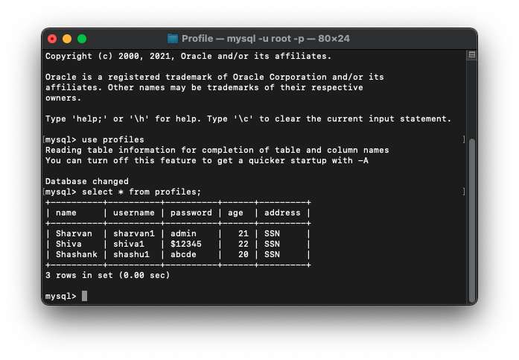

**Logging in as sharvan1:**

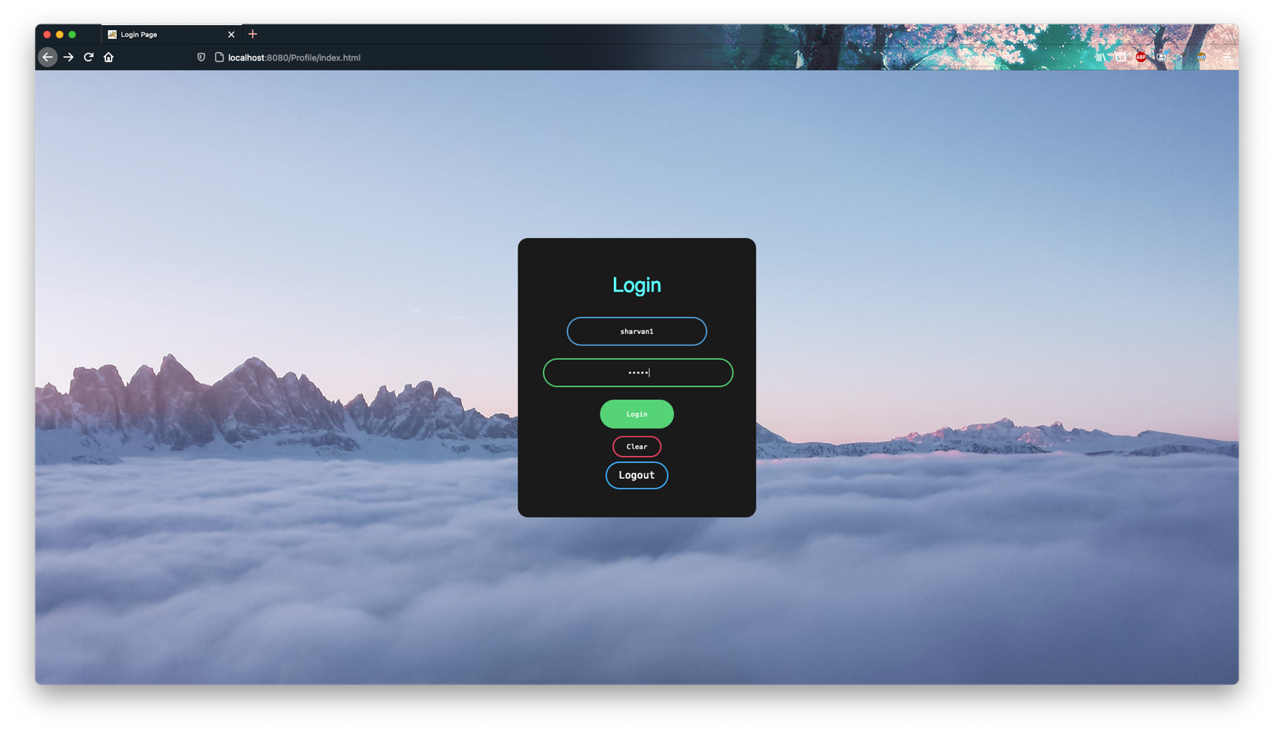

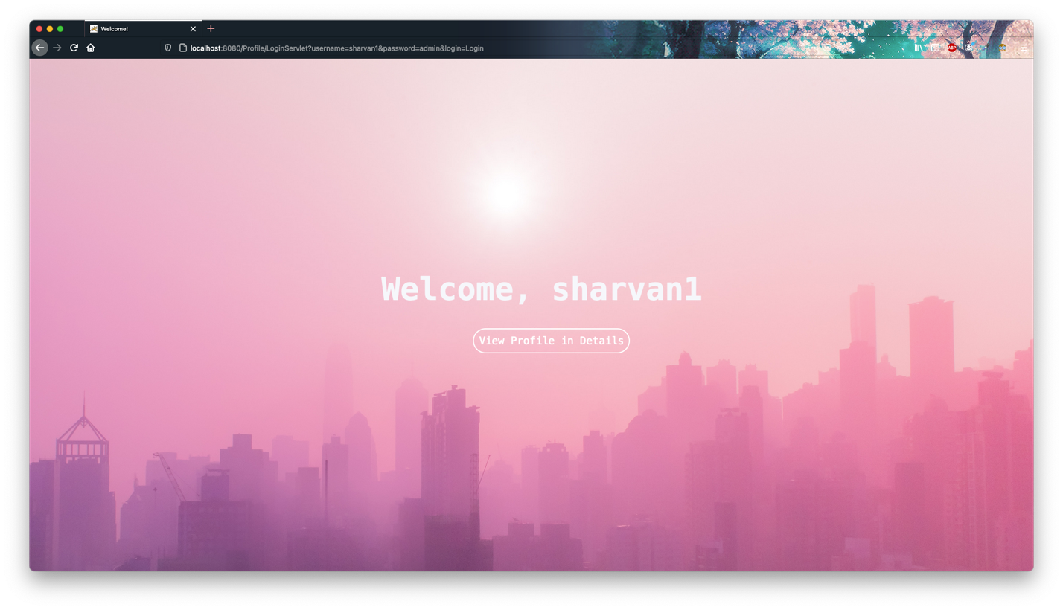

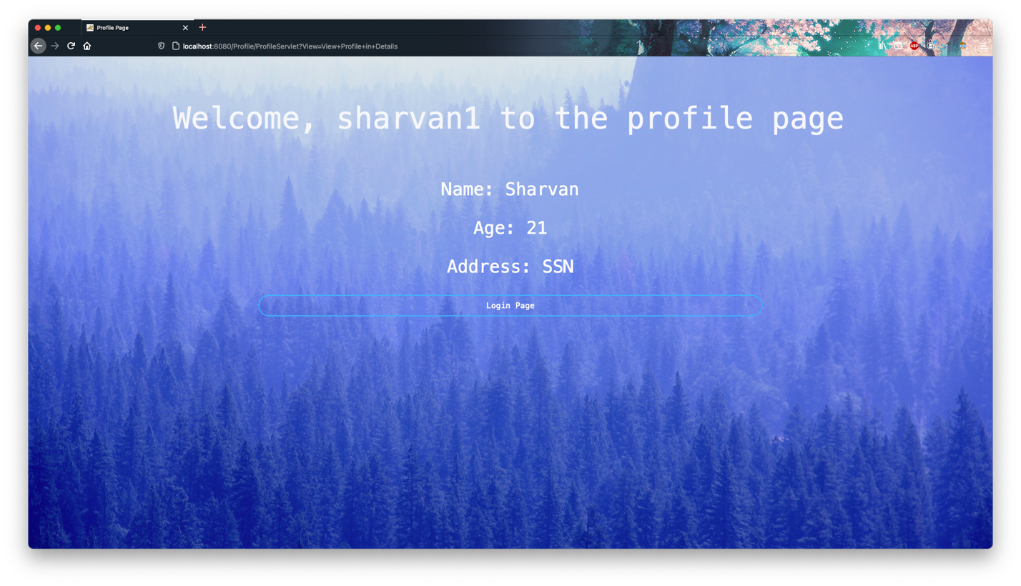

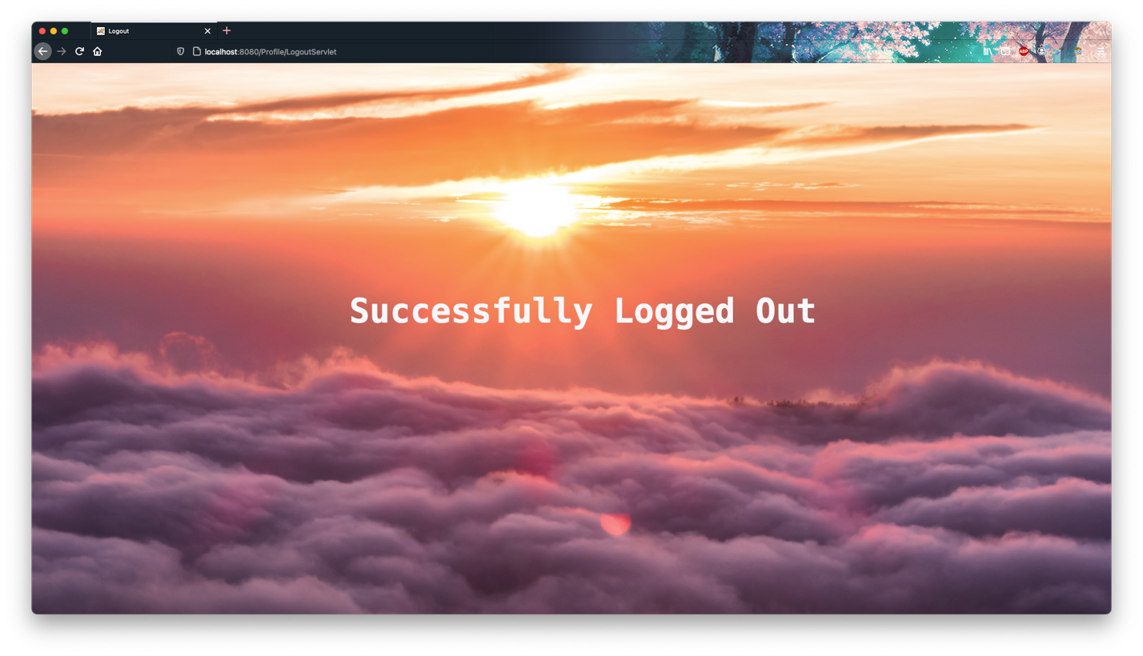

**Logging in as shiva1:**

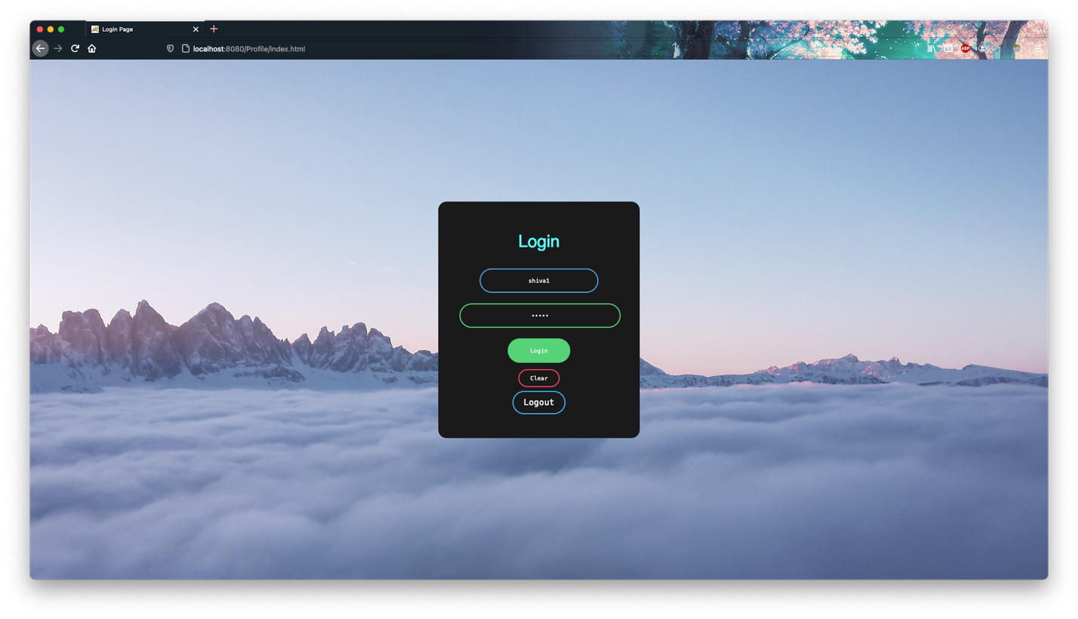

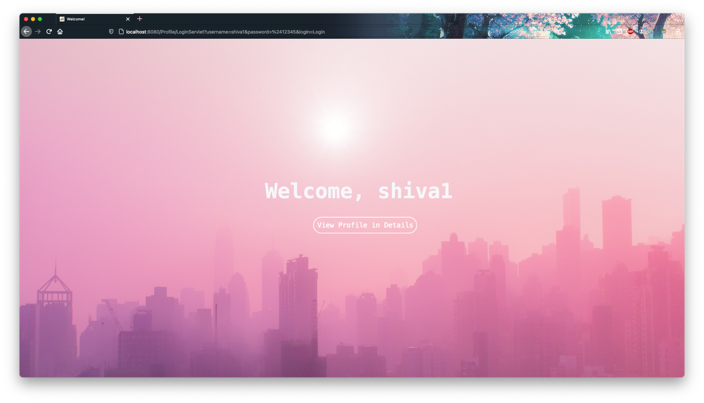

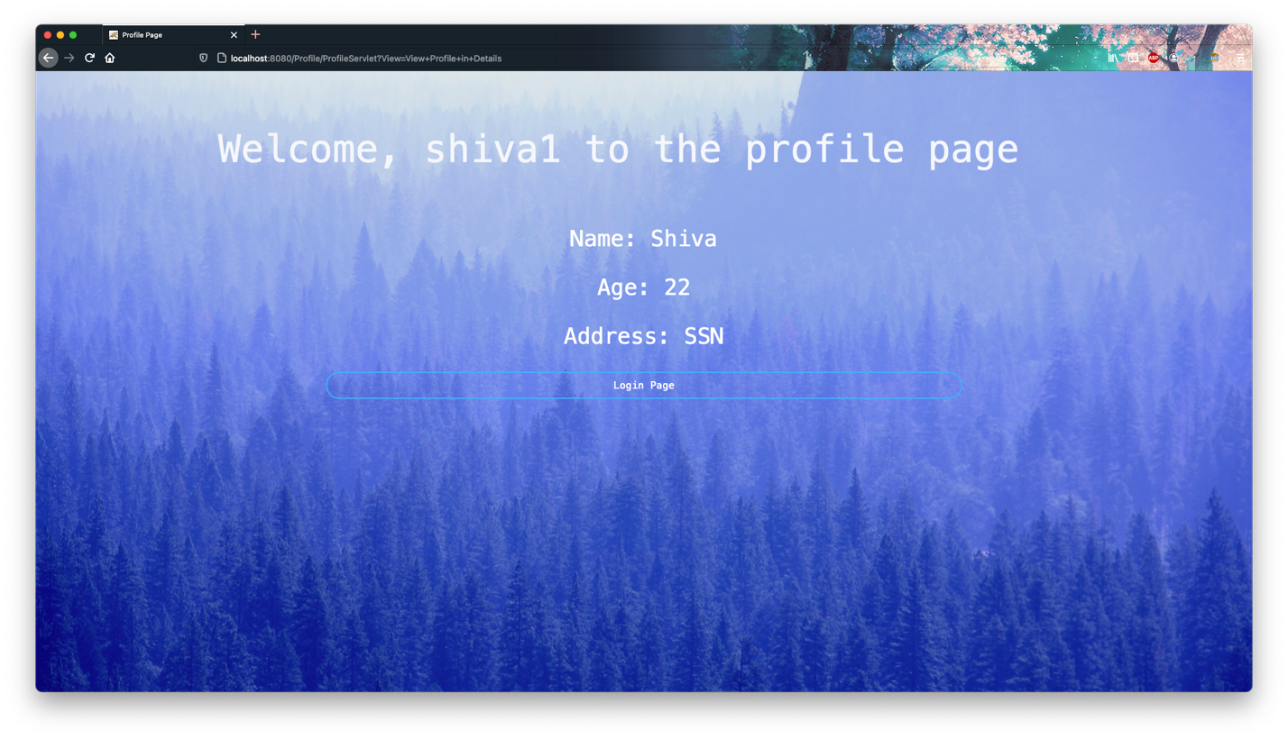

**Learning Objective:**

The profile servlet was implemented using Http Sessions.